CLASS -VII SUBJECT: Physics
Unit - LIGHT

Fill in the blanks.
(a). Light travels along a path. (b). Speed of light in air is .
- Light is composed of tiny particles called .
- An image that cannot be obtained on a screen is called . (e). The image formed in pinhole camera is .

State whether following statements are true or false

(a). A real image cannot be obtained on a screen. (b). Light travels in a circular path.
(c). The direction of light can be changed with the help of a mirror. (d). Right hand appears left in its image.
(e). We can see a candle through a straight pipe but not through a bent pipe.

Answer the following questions.
- State two properties of light? ………………………………………………………………………………………………………………………………..
……………………………………………………………………………………………………………………………
……………………………………………………………………………………………………………………………….
……………………………………………………………………………………………………………………………….
- Suggest an activity which shows that light travels along a straight path. Explain.
………………………………………………………………………………………………………………………………..
……………………………………………………………………………………………………………………………….
……………………………………………………………………………………………………………………………….
……………………………………………………………………………………………………………………………….
(c)What is reflection of light? How does it take place.?
………………………………………………………………………………………………………………………………..
……………………………………………………………………………………………………………………………….
………………………………………………………………………………………………………………………………
(d). What is refraction of light.?
………………………………………………………………………………………………………………………………..
……………………………………………………………………………………………………………………………….
……………………………………………………………………………………………………………………………….
……………………………………………………………………………………………………………………………….

(e). Write the characteristics of image formed by a plane mirror.
………………………………………………………………………………………………………………………………..
……………………………………………………………………………………………………………………………….
……………………………………………………………………………………………………………………………….
…………………………………………………………………………………………………………………………………
Q4. a) Angle of incidence = ___________.
(b) The incident ray, the reflected ray and the normal lie in one ______.
(c) The image formed by a plane mirror is at a distance behind the mirror as ___________.
(d) The image formed by a plane mirror is erect and ______.
(e) We can see the objects around us due to ______ reflection.
(f) A ______ image cannot be obtained on a screen.
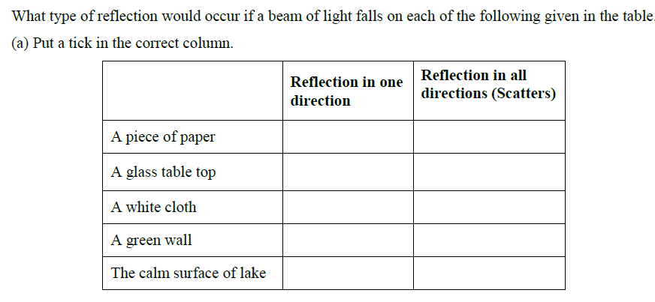
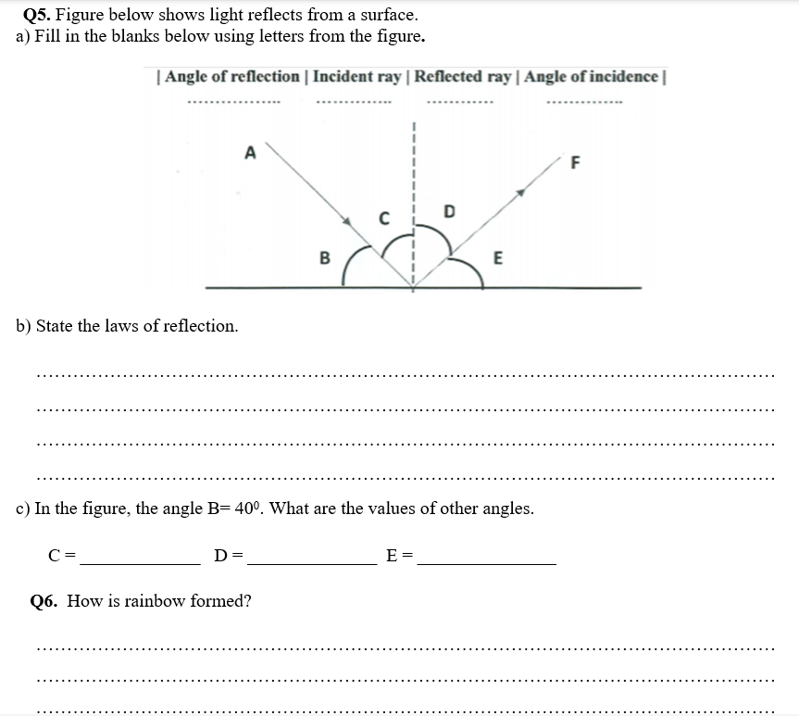

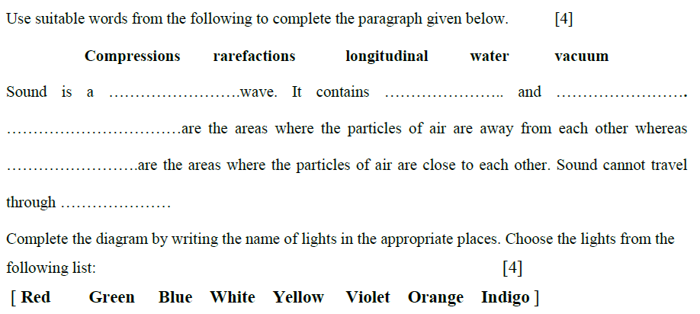
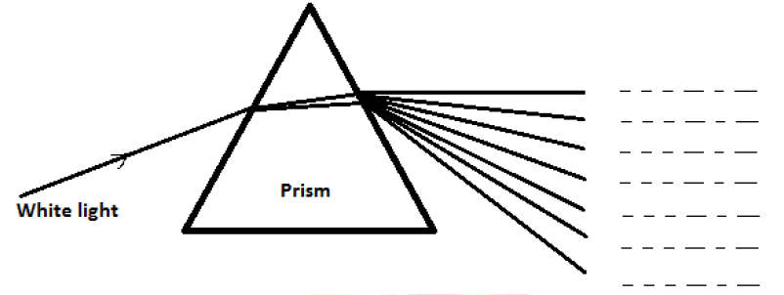

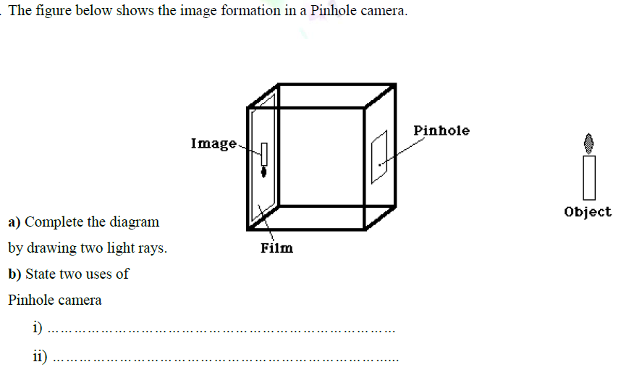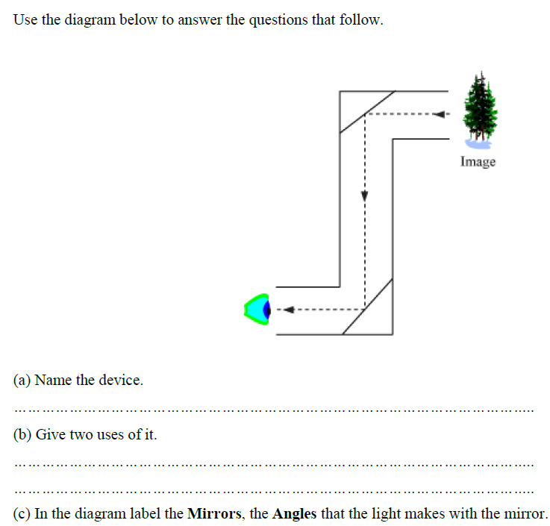

Types of lenses

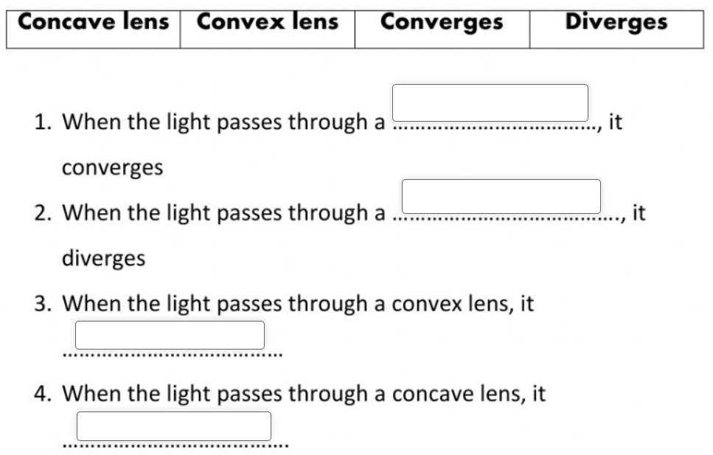

Identify the lenses.
